- Abstract
- Intro- bistability in perception often shows buildup (auditory specific or general – list examples?)
- Methods
  - ARP model- imagine z(t) is a random variable representing whether or not a percept is split at a particular moment in time. Thus z takes on values {0,1} with random durations at T0 and T1. The value z(t=0) is known to always be 0. The durations T1 and T0 are gamma distributed, such that

The distribution of durations of grouped percepts, T0, has parameters and the parameters for the distribution of durations of split percepts, T1 are . A solution exists for , aka the buildup function. We can write this solution analytically in the Fourier domain as
where is the Fourier transform of the gamma distribution, and is the Fourier transform of the complementary cumulative distribution function, .
  - competition model- ad hoc neuronal-like network
    - description:
    - analysis: The simulated timecourses of population firing rates were converted to binary timecourses relating when one population's firing rate was higher than the other's, and from these we calculated the distribution of dominance durations. The population with the first dominance epoch was arbitrarily labelled “coherent,” except when the input current to each population was mismatched. In this case, one population was always labelled “coherent”, and simulation runs in which the other population attained dominance first by chance were discarded. We averaged over switches into integration to produce buildup functions, and used MLE gamma parameters from the dominance duration distributions to generate ARP predictions.
      - I want to work out the trial-averaged version of this for simplicity of explanation's sake
    - regimes:
- Results
  - noise-driven vs adaptation-driven switching
    - correlations

- Discussion
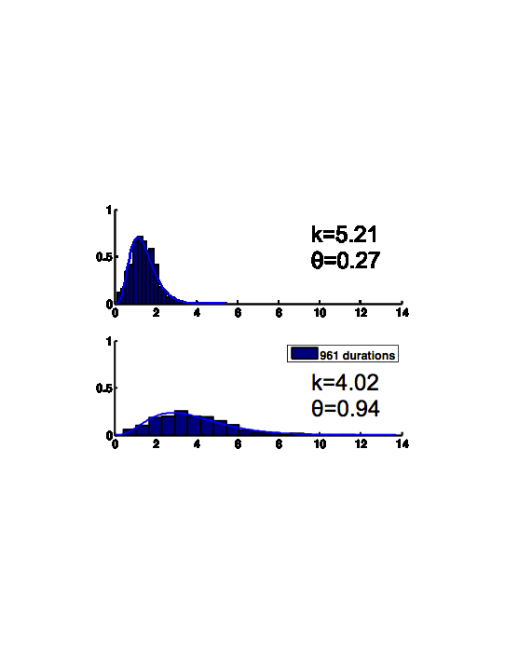
- Conclusions

I1 = 0.7, I2 = 0.55

